**Title: Service Management Strategy Report for Jollibee**

**Group name: PEACE**

**Group members:**

**张雨桐 ZHANG YUTONG 1220013708**

**余城毅 YU CHENGYI 1220031865**

**赵毅 ZHAO YI 1220005384**

**张展浩 ZHANG ZHANHAO 1220008831**

**Course name: SERVICE MANAGEMENT IN HOTEL AND TOURISM INDUSTRY**

**Instructor name: Dr. Sung Kyong Sik**

**Date: 2024.4.16**

**Service Management Strategy Report for Jollibee**

**Introduction**

This report presents a comprehensive service management strategy for Jollibee, a renowned fast-food chain. We aim to increase Jollibee's market share and explore new brand and product development opportunities. Through a macro-environment trend analysis, mystery shopping, and SWOT analysis, we will identify areas for improvement and formulate recommendations. By applying the service profit value chain model, we will outline strategies to enhance Jollibee's overall financial success. Let's dive into the details and propel Jollibee towards continued growth and profitability.

**1.Target Organization (YU CHENGYI)**

Jollibee is a fast-food restaurant belongs to Jollibee Foods Corporation (JFC) a global fast-food brand known for its Filipino-style menu items. It is one of the largest quick-service restaurants in the country and it also expanded internationally, known for its signature dishes such as Chickonjoy, Jolly Spaghetti and Yumburger. JFC also operates various other brands, including Chowking, Greenwich, Red Ribbon, and Mang Inasal.

**2.Objective**

The primary objective is to increase Jollibee’s market share by enhancing brand loyalty and customer engagement. This will be achieved through a focus on enhancing customer experience, improving operational efficiency, and expanding the customer base. By delivering exceptional service and maintaining a strong brand image, we aim to attract more customers and increase their loyalty.

Additionally, the development of new products that align with current health trends and consumer preferences is targeted.

**3.Macro-environment Trend Analysis**

**• Demographic Trends:** Understanding the changing demographics of our target market is crucial for our service management strategy. The age structure, urbanization and culture diversity which influence consumer behavior and preferences. The millennial and Gen Z cohorts are becoming the predominant consumer groups, characterized by their taste and preference for convenience. Jollibee can tailor its marketing strategies to appeal to these younger demographics by emphasizing digital engagement and highlighting sustainable practices. Urbanization is also a crucial factor. As more individuals move to urban areas, the demand for fast-food services increases. Jollibee’s strategic location of outlets in high-density cities positions it to capture this growing segment. Additionally, urban consumers tend to have higher disposable incomes, allowing Jollibee to explore premium menu options. What’s more noticeable is the cultural diversity. With the rise in multicultural societies, especially in regions where Jollibee is expanding, like Macau and Hong Kong, necessitates a nuanced understanding of local tastes and preferences. Jollibee’s ability to adapt its menu to local flavors while maintaining its core offerings is crucial in attracting and retaining a diverse customer base.

**• Economic Trends:** With the fluctuating economy, GDP growth, inflation rates, and consumer spending patterns will be analyzed to ensure that our pricing strategies remain competitive and affordable for our target customers. The fast-food industry has witnessed significant changes in recent years, with economic trends playing a pivotal role in shaping consumer behavior. The global fast-food market size was valued at USD 862.05 billion in 2020 and is projected to grow to USD 1,467.04 billion by 2028, at a CAGR of 6.05% during the 2021-2028 period2. This growth is driven by a rise in consumer spending and the increasing influence of food delivery applications. In the wake of the COVID-19 pandemic, the industry saw a shift towards delivery and take-away services, with lockdowns and social distancing measures reducing foot traffic to physical stores. However, as restrictions eased, there was a resurgence in in-person dining experiences. Consumers, particularly millennials, have shown a preference for convenience foods and on-the-go snacks, which aligns with the busy lifestyles and expanding working populations globally.

**• Technological Trends:** In the digital age, it is essential for service organizations to embrace new technology to enhance operational efficiency and meet customer expectations.Leveraging data analytics to gain insights into customer preferences and behavior, allowing us to personalize our offerings and marketing campaigns. What’s more notably is streamlining processes or embracing new technology to reduce wait times and improve service delivery.

**• Sustainability and Social Responsibility:** With the growing concern for environmental sustainability and social responsibility, company should incorporate these values into our service management strategy. Sustainability in service management refers to the ability of a company to manage its operations in a way that is environmentally sound, socially equitable, and economically viable. Social responsibility, on the other hand, involves a company’s commitment to act ethically and contribute to economic development while improving the quality of life of its workforce, their families, the local community, and society at large. In the fast food industry, this includes initiatives such as using eco-friendly packaging materials to reduce carbon footprint, using biodegradable packaging and minimizing food waste. Social responsibility could include fair labor practices, providing healthy meal options and supporting local farmers.

**4.Jollibee's Competitors (ZHANG ZHANHAO)**

In the fast-food delivery industry, McDonald's and KFC are often the first brands that come to mind. It is important to consider both options when deciding. However, in Philippines, Jollibee is a major player and competitor to McDonald's. While McDonald's has the advantage of a large overseas market and an excellent R&D team, Jollibee has its own strengths and weaknesses. Let’s use swot to analyze Jollibee's main competitor, McDonald's.

Firstly, McDonald's biggest advantage is its research and development ability and market share. McDonald's innovation labs at their U.S. headquarters focus on global market research and development, while the Hong Kong studio concentrates on food styles in the Asia-Pacific, Middle East, and South Africa regions. The R&D team at McDonald's consists of chefs and dietitians who constantly communicate to assess the feasibility of ideas. Their staff members often receive consumers’ testing and feedback. This provides McDonald's with a worldwide market which cater to local preferences while maintaining its unique identity.

However, McDonald’s also has some weaknesses. Its lags Jollibee in terms of brand development speed, as it takes up to six months to develop a new product, while Jollibee only requires one and a half months to launch a brand-new product(Lin Fenghua, 2008).

While in the drastically increasing globalization economy, McDonald's has embraced many opportunities. It could take the advantages of growth opportunities in expanding markets and attract more consumers by adapting to local tastes and cultures(LIN Zi&Chen Juezhong, 2008).

Finally, in the aspects of threat, McDonald's is now facing harsh competition from numerous locally focused fast-food brands, such as Jollibee. This makes it difficult for them to monopolize the local market, despite having their own shops worldwide.

**5.Analyzing Strategic Service Vision Target Market Segments**

Jollibee's users share common characteristics. They are digital users who use their smartphones to order and pay online. Most of Jollibee's consumers are young people and office workers who prefer takeaway for their dietary needs. Users are emphasizing on the convenience and simplified operations for purchase and payment. On time delivery is also essential to meet their immediate needs. It is probably that most of the users are in urban areas as these individuals tend to have busier schedules and require convenient takeaway services to meet their needs.

**Consumer Characteristics Segmentation:**

**• Student segment:** For college and high school students, who generally seek affordability and taste in goods. Focus on good quality and low-price snacks. Therefore, Jollibee provides convenient and affordable takeaway services, regular launches. Therefore, exclusive promotions for students to meet the needs of this group.

**• White-collar workers:** White-collar workers usually focus on the convenience of meals, and they need goods to be delivered quickly while guaranteeing the quality so that they can have their meals. Focusing on meeting the needs of busy white-collar workers, Jollibee offers fast delivery, quality meal choices and personalized ordering services.

**• Home Users:** Home users usually choose fast food services for friends when get-together or on weekends. They focus on the taste and portion size of the dishes. That's why Jollibee provides large portion dishes, set menus and special services for family gatherings that are suitable for family meals.

**Dietary preference segmentation:**

**Healthy eating group:** some consumers focus on healthy eating, they tend to prefer low calorie, high protein, and nutritious dishes. For consumers seeking healthy diets, Jollibee offers low-calories, organic, vegetarian, or special dietary requirement dishes. They also sell fat-reducing meals to cater for this group of people.

**Food Lovers:** For some food lovers, Jollibee focuses on promoting popular cuisines, special dishes, and high-quality dining experiences to attract consumers who are in pursuit of good food.

In order to meet the needs of users in different market segments, Jollibee focuses on the following services

**• Fast and Convenient Takeaway Service:** Jollibee enables users to browse menus conveniently, their designers place orders and make payments easily through providing simple and easy-to-use mobile applications and websites. Users can use Jollibee APP to order food anytime and anywhere to meet their urgent needs in their busy lives. This convenience is recognized and enjoyed by customers.

**• Diverse dining options:** Jollibee has partnered with many restaurants to offer a wide variety of menu options covering a wide range of tastes and dining types, including Chinese, Western, fast food, desserts and more. This diversity enables users to choose the right catering option according to their tastes and preferences.

**• Efficient Delivery Service:** Jollibee has established an efficient delivery network, working with restaurants and delivery staff to ensure that food reaches users’ venue on time. They may utilize intelligent scheduling systems and real-time tracking technology to improve delivery efficiency and reduce delivery time. Users also are able to access prompt and reliable delivery services, which is important to satisfy their food cravings and time requirements.

**• Premium food quality:** Jollibee may have established stable supply chain partnerships with restaurants to ensure that the quality of food provided meets users' expectations. They may work with restaurants to develop standards and processes, oversee the sourcing and handling of ingredients, and ensure that food remains fresh and hygienic during delivery. User acceptance of the quality and taste of the food is critical to Jollibee's success.

**• User Satisfaction:** Jollibee's user satisfaction is an important indicator for assessing its business performance. Jollibee may collect user feedback and take steps to improve the user experience. This may include improving the quality of food, enhancing the accuracy and timeliness of delivery services, providing good customer support, and resolving user complaints and problems. Increased user satisfaction could help Jollibee to build a good brand reputation and promote user loyalty.

**6.SWOT Analysis (ZHANG YUTONG)**

**Strengths**

In terms of products, Jollibee has launched a creamy sauce with a unique mashed potato flavor, paired with crispy fried chicken, which is very delicious and tempting. Due to the large amount of this sauce, sometimes people already finished the fried chicken and there is still leftover some sauce. Therefore, people have shared various novel eating methods they have invented online, such as mixing rice, dipping French fries, frying beef and frying mushrooms. Some people even say they will drink the sauce directly. This shows that it is very delicious and can work well with various foods, which is an important reason why Jollibee is famous.

In terms of brand promotion, Jollibee is a brand from the Philippines, and the international reputation of Filipino cuisine is not very high. Therefore, many customers are curious about this and choose Jollibee. This also made customers realize that Jollibee’s dishes are different from the familiar American fried chicken (such as McDonald’s) and Korean fried chicken. It is a brand new flavor. In the Jollibee’s physical store in Macau, we found that the restaurant staff were all Filipinos, successfully providing customers with a localized special experience. This special culture has become their unique resources, giving them more opportunities to engage in commercial cooperation with specialty restaurants from various regions.

About service, Jollibee adheres and commits to its “high standards as symbolized by “F.S.C.”: Food (F) served to the public must meet the company’s excellence standards or it will not be served at all; the Service (S) must be fast and courteous; and Cleanliness (C), from kitchen to utensils, must always be maintained. Jollibee is proud of its employees who carry out their jobs” (Jollibee website). To achieve the F.S.C. standards, high-quality ingredients are sourced from its supply chain and prepared at its commissaries for final cooking in the stores. Jollibee invests in technology in food processing and other food-service innovations, as well as the latest in-store operations systems (e.g., digitized touchscreen ordering system, digital menu board, cashless payment system, etc.). Employees are regularly trained to familiarize themselves with these in-store innovations (Gutierrez, 2021).

About employee welfare and benefits, Jollibee’s owners treat the employees as family. Employees are their partners in delivering Jollibee’s mission of serving great tasting food, bringing the joy of eating to everyone (Jollibee website). Jollibee recognizes and retains its employees by offering them the highest compensation and benefits packages in the fast-food industry and equipping them with modern and comprehensive training programs (Jollibee website) (Gutierrez, 2021). Jollibee can be called a “caring enterprise”. The extremely high employee recognition and satisfaction have also increased the motivation for sustainable development.

**Weaknesses**

In this part, we analyze from two aspects: the problems faced by Jollibee and the potential problems in the fast food market. We will start from the Jollibee’s problems.

Firstly, we observed that the limited products and collaborative activities of Jollibee are rare, lacking creativity and attractiveness. For old customers, over time, they may lack freshness, become bored, and for new customers, there may not be a strong attraction to them. We believe that Jollibee can leverage its unique cultural advantages, increase cooperation with other brands, launch co-branded products, regional and seasonal limited products, increase selling points, and attract more customers.

Secondly, the number of Jollibee’s physical stores is less than that of other well-known fast-food brands, and they have not opened in Chinese Mainland, South Korea, Japan, Australia, and other well-known countries (regions). However, the fast-food market in these places has been almost occupied. If Jollibee wants to expand their business in the future, they need to cross a higher threshold, improve product quality, show greater attraction and creativity in product design and service, improve its irreplaceable ability, and win the market for themself.

Finally, we observed that Jollibee’s advertising style is singular. On Instagram, a social media platform, the overall style of advertisements posted on the official account of Jollibee is very similar, mostly with a red background, accompanied by photos of dishes and promotional slogans. Compared to McDonald’s, we found that its promotional style is diverse and very creative, and collaborating with various IPs can greatly enhance people’s desire to consume. Therefore, we believe that Jollibee can change their advertising style and increase their level of creativity.

Next, we will discuss the potential problems in the fast-food market.

According to Kara, Kaynak and Kucukemiroglu (1995), people believe that these eleven attributes are the reason why they like fast food restaurants or not: price, friendliness of personnel, variety of menu, service speed, calorie content, cleanliness, convenience, business hours, delivery service, novelties for children and seating facilities. So we can infer that people in the fast food market likely to see expensive, poor service attitude, slow food delivery, unhygienic, inconvenient and other details that have not been considered by restaurants as weaknesses. All these factors may cause restaurants lose sales. Therefore, it is obvious that Jollibee should focus on improving various services to avoid these situations and ensure profitability.

**Opportunities**

In previous part of the report, we analyzed the current trends in the fast-food market from the perspective of demographic, economic, sustainability and social responsibility. We found that young people are the main consumer group, people are back to dine-in because the end of COVID-19 restrictions, and people’s attention to environmental sustainability is increasing. Most importantly, the rapid development of digital technology. We believe that Jollibee should follow these trends and gain recognition from consumers and society while gaining profits.

In our opinion, the development of technology offers us new service options. Jollibee has opened a food delivery service, which allows people to order through the app or official website then have meals at their home. In the physical store, ordering machines have also been launched to improve service efficiency. Nowadays, many people rely on navigation to find all kinds of destinations, so Jollibee should ensure that every physical store can be accurately located through navigation, especially in places like Macau where the streets are narrow, and stores are dense. Consumers can easily find physical stores is an important factor to improve their satisfaction.

Also, we found that the competitors of Jollibee have the problem of having a single type of staple food, which is also provide niches in the fast-food market that Jollibee can fill suitably. The common Western fast food on the market mostly has a single type of staple food only, such as McDonald’s, KFC, and Burger King, which only have hamburgers. While Jollibee has hamburgers, rice, and pasta. All three types of staple food are widely praised. Jollibee provides consumers more choices and it is more suitable for group dining, which is very advantageous and can fill the market niches.

**Threats**

We believe that Jollibee is currently facing three major obstacles. First, its competitors are very strong, so it is difficult to catch up with them. Second, it is difficult to expand the market. For example, foreign enterprises in Chinese Mainland are currently facing various challenges. Last, Jollibee’s position threatened by changing technology. We must keep up with the times, combine services with technology, in order not to be eliminated.

First, according to the analysis in previous part of our report, we have learned that McDonald’s is one of the competitors of Jollibee. They have a professional team dedicated to developing dishes for different regional flavors, continuously launching limited and co-branded dishes, and expanding globally. In Macau, there are 61 McDonald’s but only 4 Jollibee’s physical stores. We believe that although it is difficult for Jollibee to surpass the powerful McDonald’s for a while, they can learn some of McDonald’s marketing strategies to help themselves make profits.

Besides, according to Froese, Sutherland, Lee, Liu and Pan (2019), we can know that foreign enterprises are facing regulatory challenges, cultural challenges, innovation management challenges and human resource management challenges right now because the “soft-landing” of the Chinese economy, the anti-globalization tendency and the situation about delivering offensive messages due to “cultural misunderstandings”. Therefore, Jollibee still has difficulties in entering the Chinese Mainland market. It needs them to find the right time to seize this huge profit opportunity. For other countries, detailed research and investigation are also necessary before considering expanding their market.

Last, changing technology can also pose a threat to us. Nowadays, there are more and more types of pre-made dishes and convenience foods, and the taste is getting better and better, and the cooking speed can even be faster than fast food. In addition, people can also order takeout and deliver it directly to their homes. Therefore, the demand for physical fast-food restaurants is gradually decreasing. Jollibee must provide convenient takeout services, including improving delivery speed, improving online ordering processes, and enhancing service efficiency, so as not to be affected by changing technology in revenue.

In terms of cash flow, Jollibee is not threatened. After the end of the COVID-19 negative impact, with the fast development of the tourism industry, the cash flow of Jollibee is normal, sufficient, and stable. The company’s capital operation is orderly, with less uncertainty and low enterprise risk.

**7.Operating Systems and Service Delivery System (Employees) (ZHAO YI)**

**Efficient operations:** Jollibee should optimize internal processes, simplify work processes, and make fast food. Well-trained staff play a vital role in providing quality services. Investing in employee training and development can improve their skills, such as fried chicken and burger preparation, steak grilling, etc., thereby providing better service.

**Employee motivation and satisfaction:** Jollibee should create a positive working environment and recognize employees' work results, such as caring about employees' working conditions when they go to work, and listening to employees' suggestions for work, such as caring for kitchen hardware facilities.

**Service Package (Service Value in Quality Cost)**

**Quality Assurance:** Jollibee must strictly ensure the quality of ingredients such as the freshness of fried chicken, the freshness of burger embryos, and the handling of daily leftover ingredients, and create its own flavor to differentiate our burgers from McDonald's.

**Pricing strategy:** Balancing price with quality is crucial. Jollibee should set competitive prices for its menu items while ensuring profitability, compared to McDonald's, making sure the quality is foolproof on the same dishes, such as chicken drumsticks, and making its own specialties and flavors.

**Target Market (Customers)**

**Segmentation and personalization:** Jollibee has identified the needs of different consumer groups (students, white-collar workers, home users, etc.). If students or children want different flavors and unique tastes, we provide a variety of choices for each package, such as beef, chicken and pork. For drinks, milk coffee, cola, sprite, orange juice, etc. are all available. For white-collar workers, Their demand is for fast food delivery, while for family customers, their demand may be good quality and low price, and they are more price sensitive, so we will carry out promotions, loyalty programs and targeted advertising at the right time. Can attract and retain specific customer groups, such as Christmas, New Year, Children's Day, Halloween, etc.

**Customer Relationship Management (CRM):** Building strong relationships with your customers is crucial. Collect data about customer preferences, order history and feedback.

**Financial Success (Revenue Growth and Profitability)**

**Revenue growth strategies:**

Market Expansion: Explore new locations or expand into underserved areas. Consider international markets if feasible.

**Menu innovation:** regularly introduce new menu items or limited-time offers to attract repeat customers such as Christmas-themed set menus, Halloween-themed restaurants, Chinese Zodiac themes, or Children's Day discounts for children, etc.

**Upsell and cross-sell:** Train employees to upsell complementary items (e.g., drinks, desserts) when interacting with customers.

**Supply chain efficiency:** Optimize procurement, inventory management and supplier relationships to reduce costs. For example, the daily stocking volume is purchased and produced based on the sales volume of fried chicken in the previous period.

**Technology investment:** Invest in POS systems, inventory management software and analysis tools, add payment methods, Alipay, WeChat and bank cards, etc.

**8.Conclusion**

The report presents a comprehensive service management strategy for Jollibee, focusing on increasing market share, enhancing brand loyalty, and exploring new product development opportunities. It includes a macro-environment trend analysis, highlighting demographic, economic, technological, and sustainability trends. The report also discusses Jollibee's competitors, with a specific focus on McDonald's.

The analysis identifies key opportunities for Jollibee, such as targeting younger demographics through digital engagement, capitalizing on urbanization and diverse consumer preferences, and adapting to changing economic trends. Embracing technology and incorporating sustainability and social responsibility into the business model are also emphasized.

Regarding competitors, McDonald's is recognized as a major player in the fast-food industry. Its strengths lie in its research and development capabilities and global market share. However, McDonald's faces challenges in brand development speed and intense competition from local fast-food brands like Jollibee.

Finding opportunities in the fast-food market is crucial to Jollibee's development. Capitalizing on current trends, such as the urgent focus on sustainability, the impact of digital technology, and the preferences of younger consumer segments, can help brands gain recognition and profitability. It is recommended to leverage technology to improve service options such as delivery services and accurate store navigation. Jollibee has the advantage of offering a variety of staple foods, including rice and pasta, and can focus on the market gaps left by competitors in a single type of fast food.

To drive revenue growth and improve profitability, Jollibee should consider market expansion, menu innovation, upsell and cross-sell strategies, supply chain efficiencies and technology investments. Exploring new locations, introducing new products, optimizing procurement and inventory management, and leveraging technology solutions will contribute to Jollibee's financial success.

**References**

Froese, F. J., Sutherland, D., Lee, J. Y., Liu, Y., & Pan, Y. (2019). Challenges for foreign companies in China: Implications for research and practice. *Asian Business & Management*, *18*, 249-262.

Gutierrez, B. P. B. (2021). Jollibee Foods Corporation.

Kara, A., Kaynak, E., & Kucukemiroglu, O. (1995). Marketing strategies for fast‐food restaurants: a customer view. *International Journal of Contemporary Hospitality Management*, *7*(4), 16-22.

LIN,F.H.(2008).Jollibee to fight McDonald's in China.*China Famous Brand*,(5),62-65.

LIN,Z.&Chen,J.Z.(2008).Jollibee Stings McDonald's Instead of Honey.*Chinese World*,(11),82-83.

**Appendix**

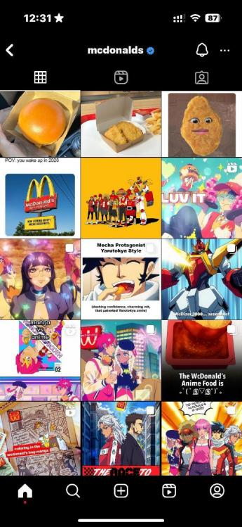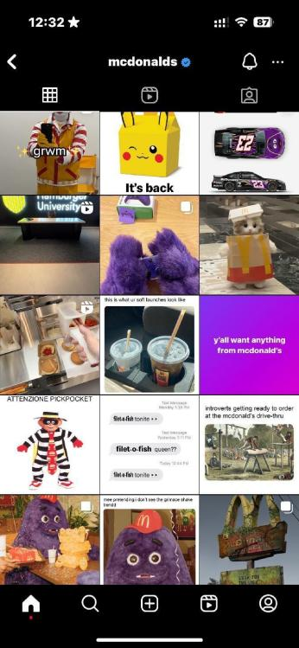 (Official Instagram account of McDonald’s)

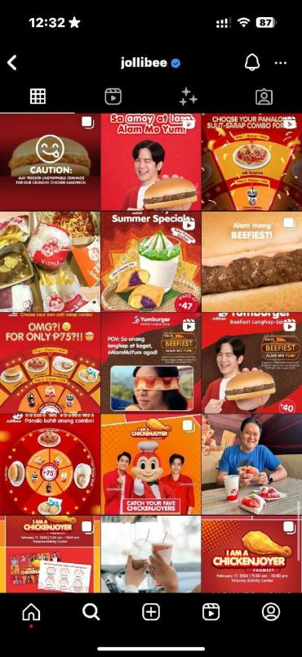 (Official Instagram account of Jollibee)

